Transaction Report Tool Tutorial:

-This tool is meant to show you different Transactions, its' contents, and a list of the related documents linked to each one. It allows to perform a smart search by fields, that returns the
candidates and classifies them by the number of similarities with the different search terms.

Main Screen:

Head to http://54.200.180.182/enersectapp/legalui/transactions_report/ .
Main Screen is as such:
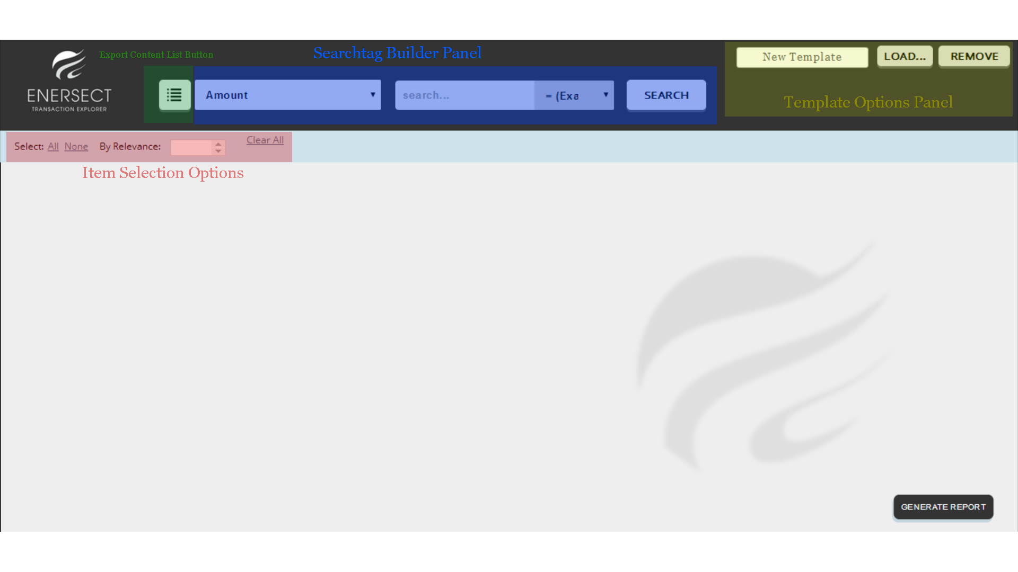
Explanation:

-Export Content List Button : Exports a .csv with all the possible results in each of the tags available. If something can be searched, it appears here.
Ex: Amount column will show all the possible Amounts one can search for.

-Searchtag Builder Panel : “Searchtags” are 3 part blocks that define the rules for searching
in the database. The 3 parts are: Field : Content : Rule. Searchtags are cummulative ; The resulting candidates of two searchtags will be shown in the same table, but with different scores depending on how many searchtags they compliment. Will be explained in more
detail later.

-Template Options Panel: Saves, loads and removes templates. Each Template saves the Searchtags used and the Candidates selected in a particular search.

-Item Selection Options: Selects all the items, none, by Relevance Score, or Clears the used Searchtags. The selected candidates can be shown in a report pressing the button Generate Report (Not available at the moment, due to big changes in the outputting format and template generation).

One possible process to search for an item in the Grande Livre corpus, and see the original PDF related to it:

1.Choose the relevant Field to search (probably Movement Number, Piece Number, Amount or CompleteDate):

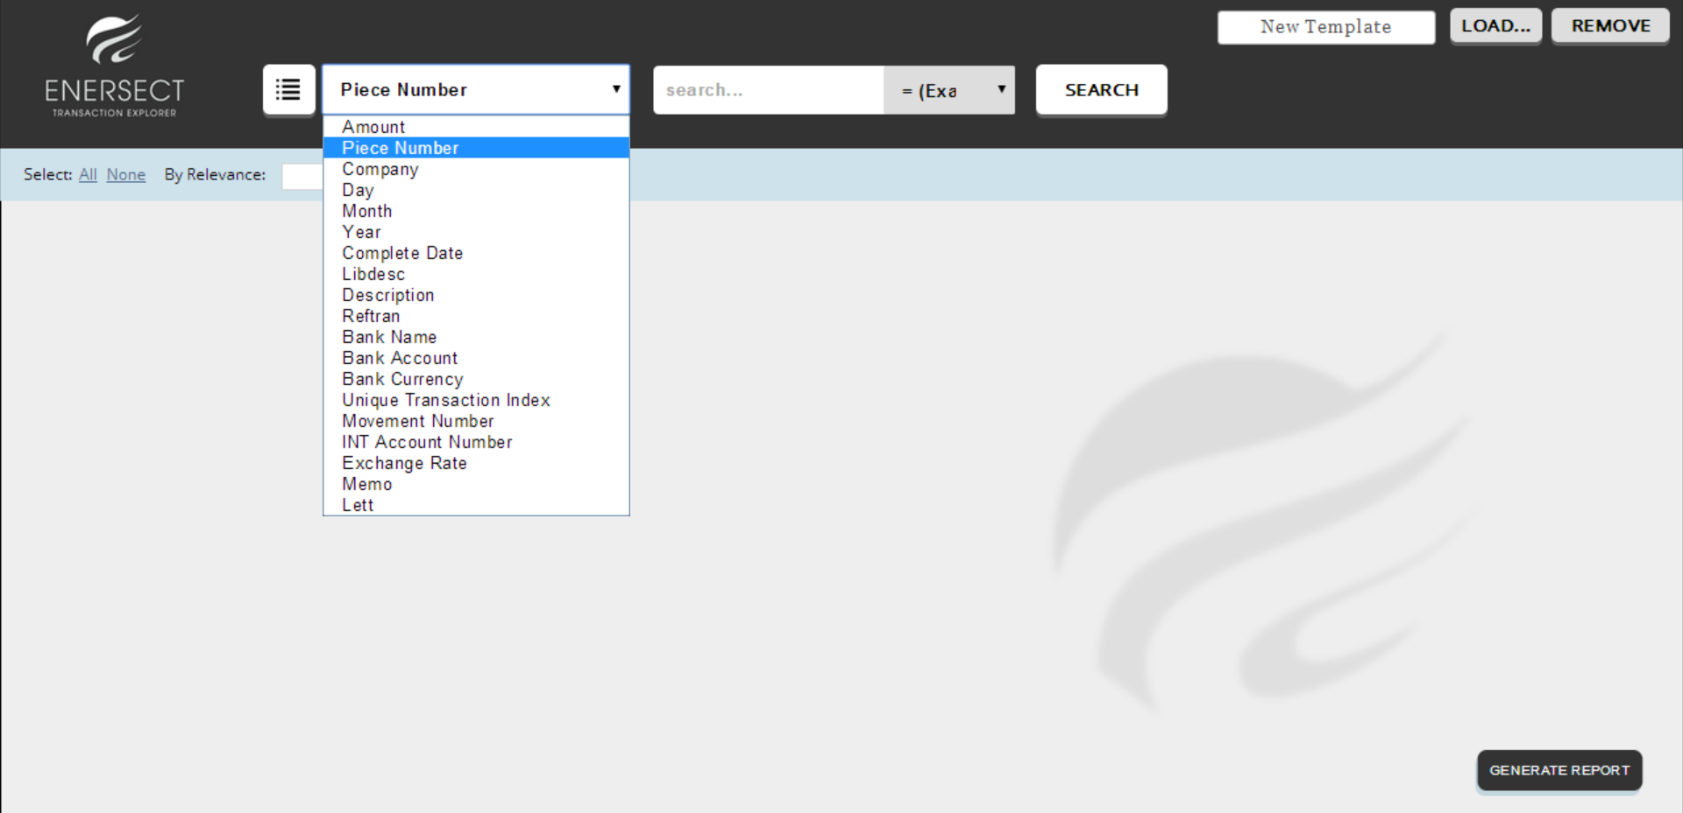
2.Fill the Content to search in that Field:

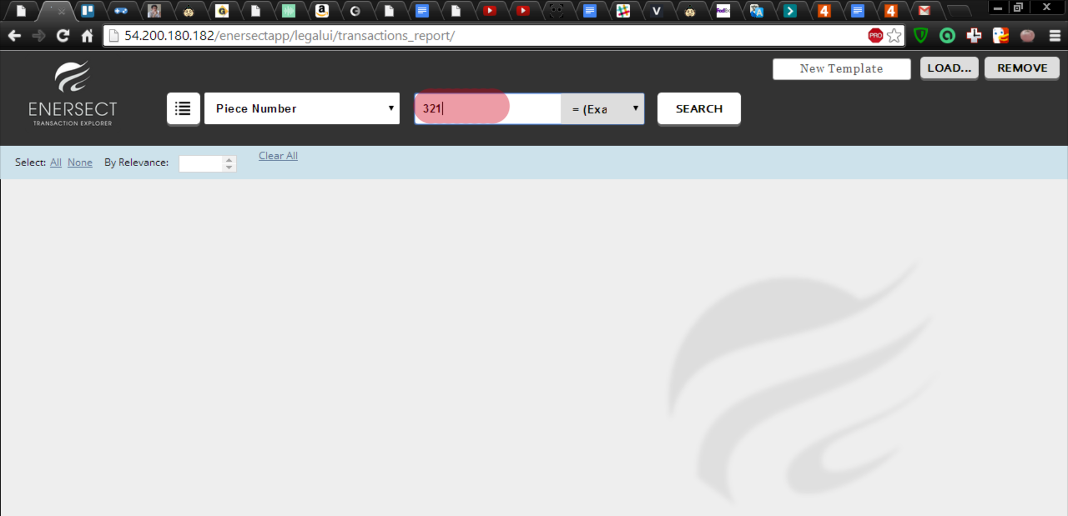

3.Choose a Rule for that search, between:
-Exact: Will only take into account items that have exactly that content. (In the example, 321 in the Piece Number)
-Contains: Will show any items that have at least that string as part of the content. (In the example, 321 in the Piece Number, and 3210 in the Piece Number, as well as 09321, etc.)
-Greater than: Will show any items whose content is bigger than the string provided. When the input is a string and not a number, an item starting with G is bigger than an item starting with B. (In the example, 325 in Piece Number, as well as 4000, etc)
-Less than: Will show any items whose content is smaller than the string provided.
Opposite of “Greater than”.
-Exclude: Will show all items except the ones containing the text provided.(In the example, items that don't have 321 in their Piece Number)

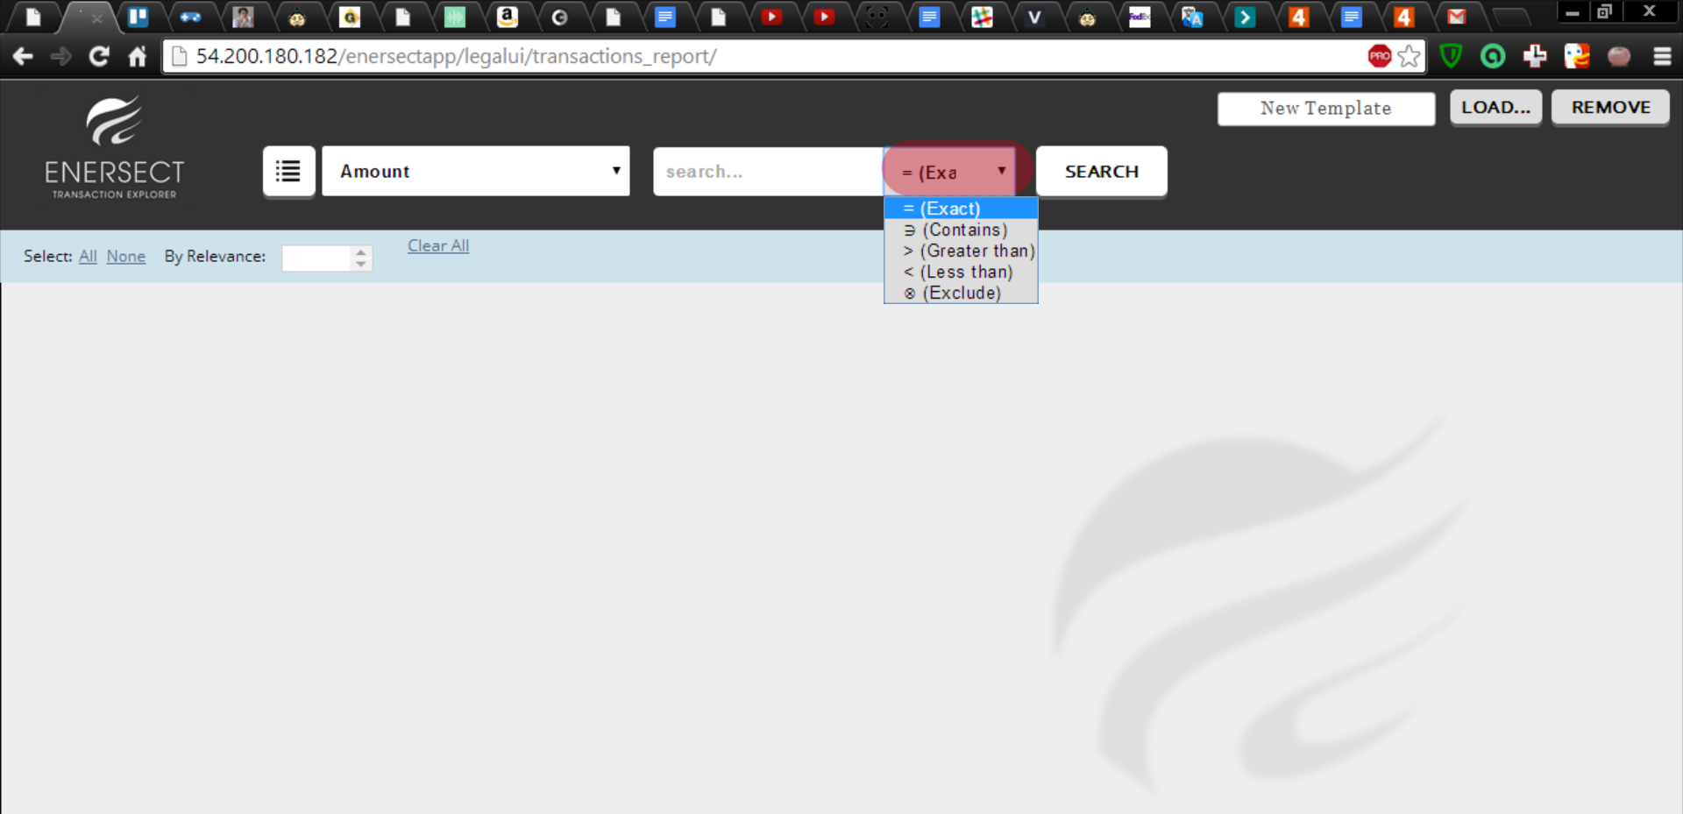
4.Press Search.

This will create a Searchtag with the specified parameters, and show all the items that meet the requisites:

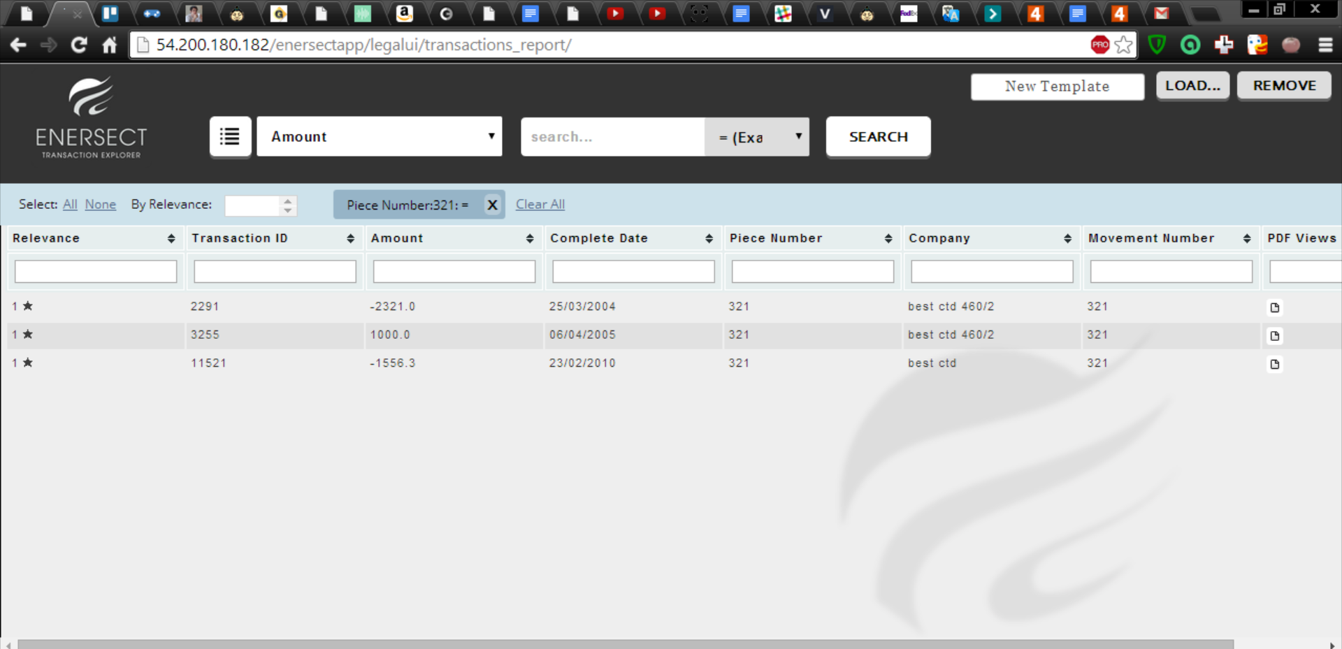
Note: If at any point we press F5, the search will be repeated, conserving the created Searchtags.

If the search wants to be refined, we can either write in the filter boxes of each field, as in this example:

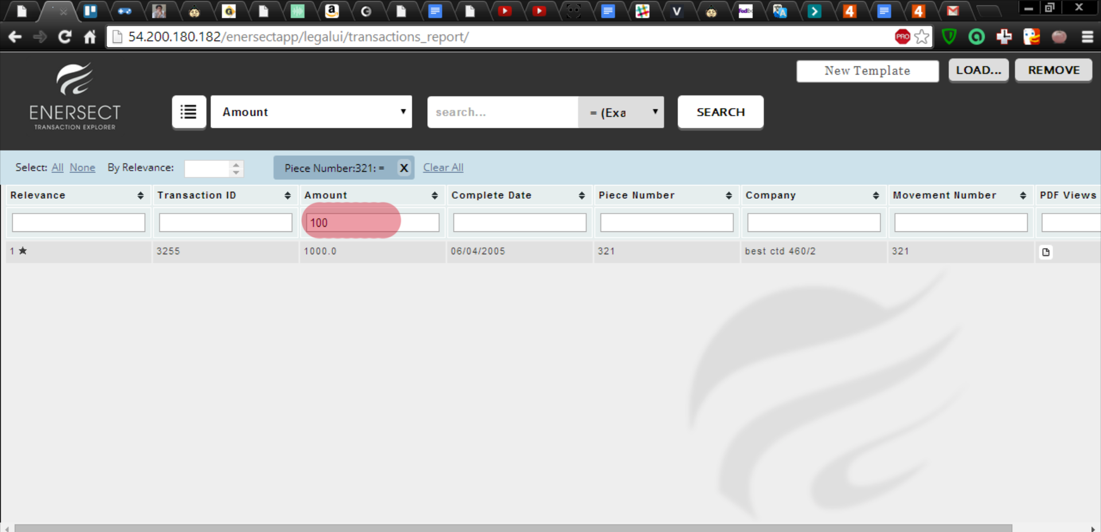
Or add a new Searchtag:

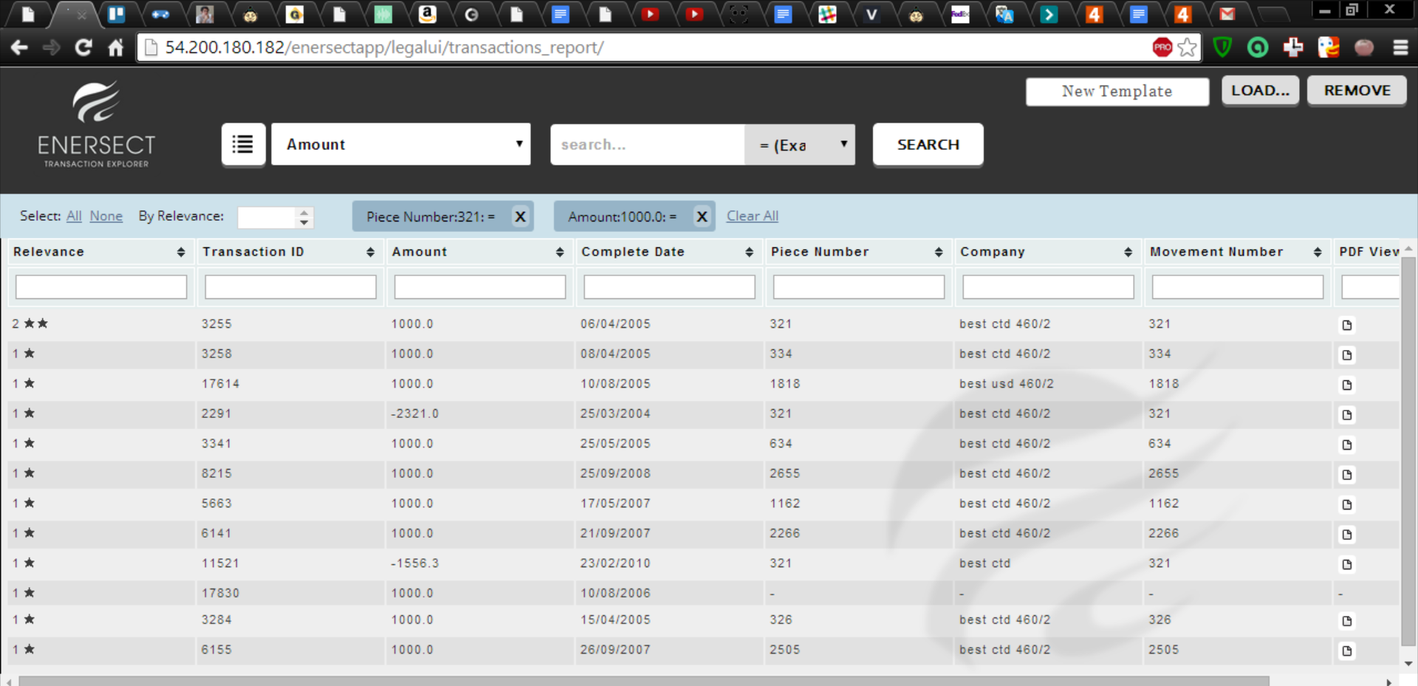
In this case, we receive all results that compliment the first Searchtag, the second one, or both.
Probably we are interested in the one that has Relevance Score of 2, as it fits both parameters.

This process allows us to create complex and flexible rules. For example, if we wanted all items betweens the Years 2003 and 2005, we would create 2 Searchtags: Year;2003;> and Year;2005;<.

The results we want would appear with a Relevance Score of 2, but we could still see the candidates fitting only one of the requisites:

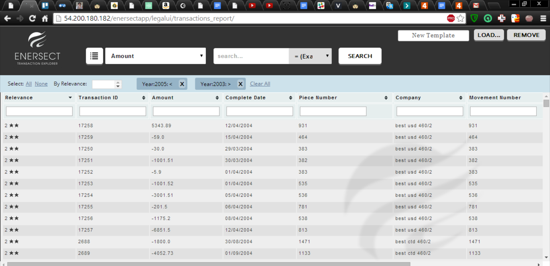

Please note that the broadest the search Rules, the bigger the processing time of the searches and sortings, as more items show up in the search.

All columns can be sorted pressing in their headers. Unfortunately, resize isn't an option, but I feel the screen space is enough to show the most important fields comfortably at any time.

To see the original PDF:

Move to the last column, “PDF Views”, and press in the button with an icon. If there is no button, this candidate isn't related to any Grande Livre record, only to the Albaraka files, which can't be seen in this way at the moment. If there is more than one button, it means that there are various Grande Livre records related to this candidate:

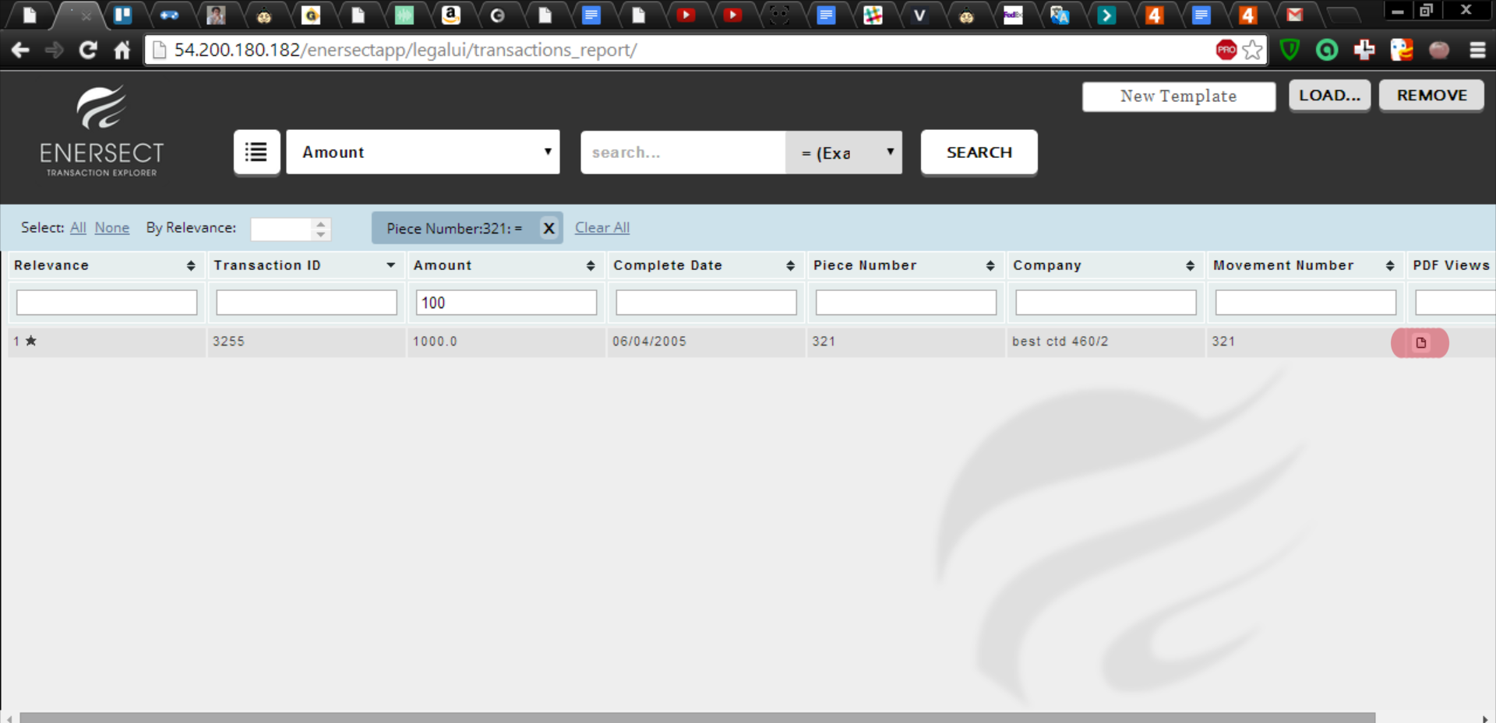

After we clicked, the window will change to show us the relevant page of the Grande Livre Ledger, in which we can explore and find our candidate:

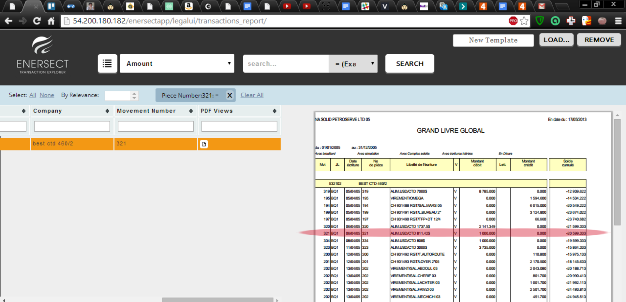
If we want to return to the original view, press the Pdf Icon again, or F5 to reset the search.

To search in the Albaraka Records, as I don't have the necessary data available yet, the original exploration method can be used: Click on the candidate, then explore the Transaction Tree:

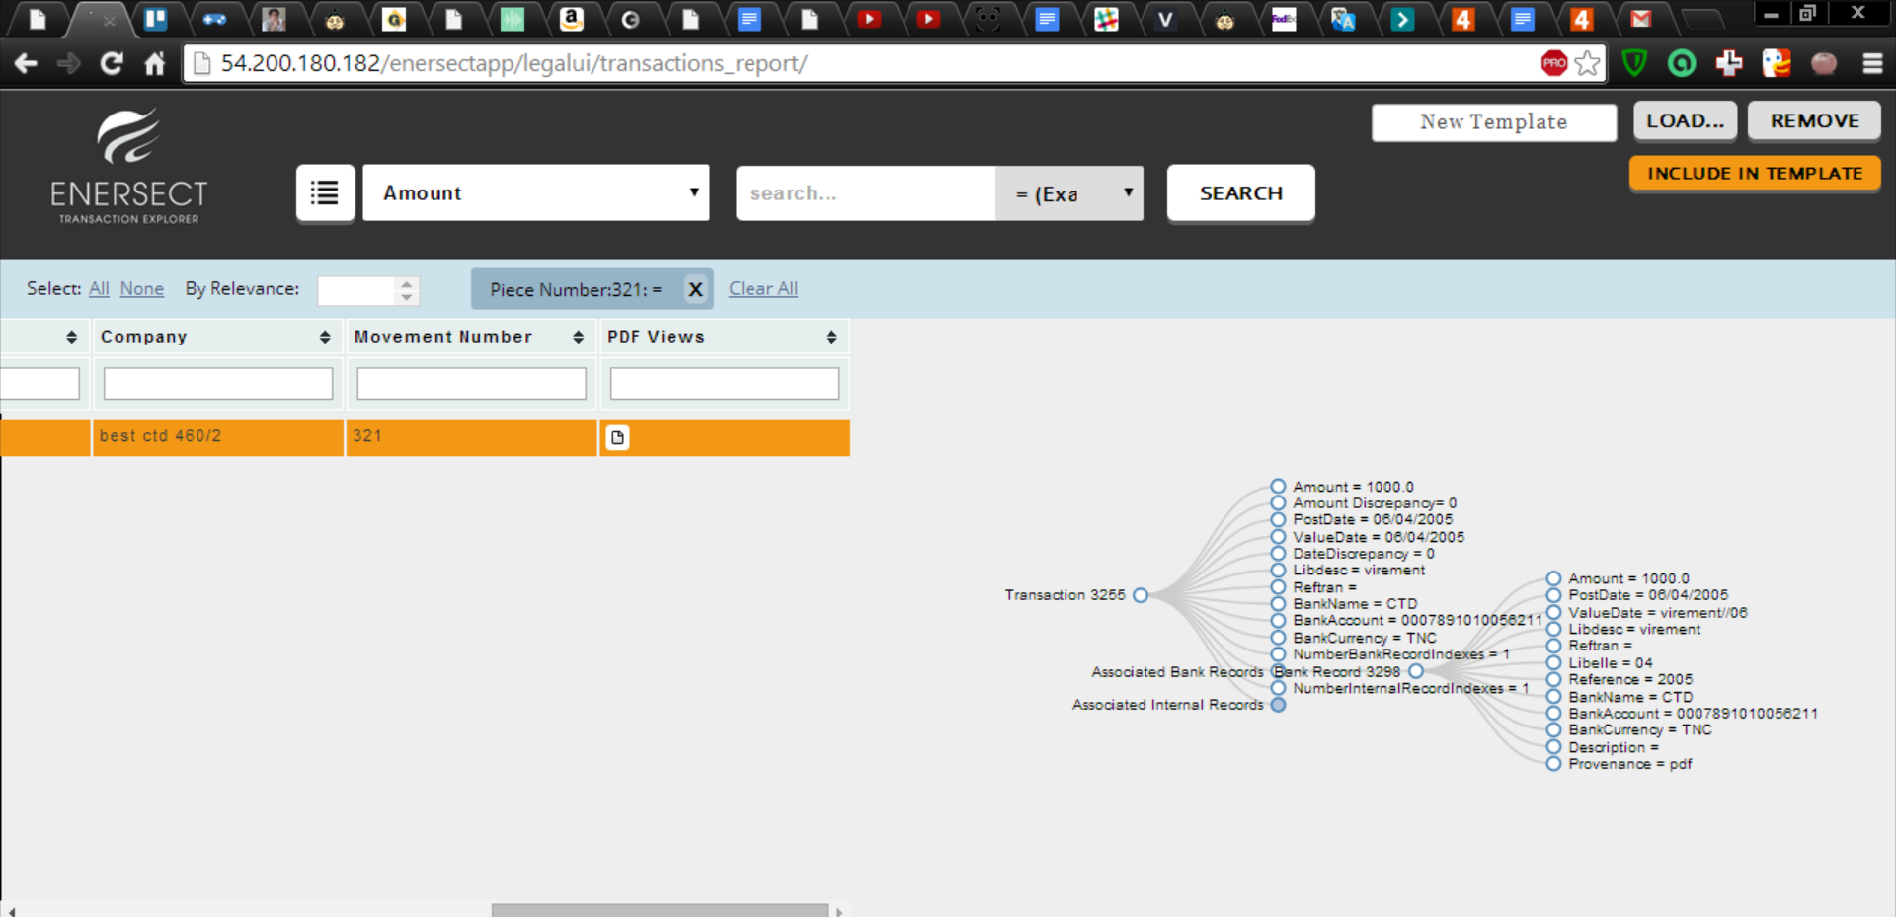
The link between the data extracted from the corpus of Pdfs (what we call Icr Records) to the Transactions or Grande Livre Records are not available to me at this moment, so can't be searched with this tool.

However, this workflow allows to find the links / exact pages manually easier than what Nathan told me you were doing, so I hope it proves useful to you! :D. Please ask me any questions necessary. Good day!

